Febrero 25th, 2021

Temperature and Humidity
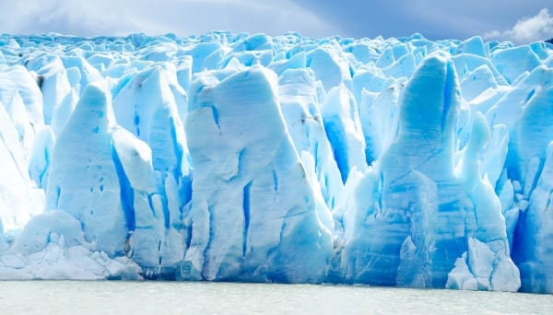
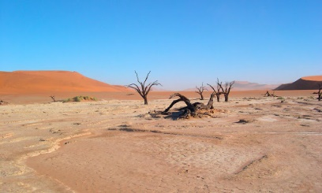

Temperature and humidity are other important characteristics of hábitats. Each animal develops and lives in a place where the temperature is night for it. During the winter, some animals change habitats to live in a warmer place. We call this migration.

Humidity is also a very important characteristic. Is a measure of the amount of water in a habitat.

Aquatic animals live in very humid places, like rivers, lakes and the ocean. Terrestrial animals live in places with less humidity.

