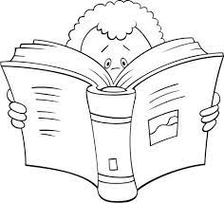
Temas Matemáticas
II Período

- La multiplicación(concepto y términos.
-Sumas abreviadas
-Tablas de multiplicar
-Multiplicaciones con 2 cifras.
- Estadística:
-Diagrama de barras
-Pictograma
-Diagrama de puntos.
- Geometría:
-Líneas (trayectoria)
-Clases de líneas
- Medición:
-Medidas arbitrarias de longitud
-Metro, cm y dm.
-Perímetro
Temas L.Castellana
II Período

- Sustantivos y clases
- Pronombres personales
- Sinónimos y antónimos
- El punto y sus clases
- La coma
- El texto instructivo
- La poesía
- Vocabulario #2
- Lecturas comprensivas
- Plan lector

Topics Science
II Period

- Human impact on environment.
-Effects on our surroundings
-Taking care of the environment,
- Endangered animals.
- Plants:
- Characteristics
- Plants parts
- Plants needs
- Plants cycle
Temas Sociales
II Período

- La comunidad:
-Familiar
-Escolar
-El barrio
- El municipio:
-Autoridades del municipio.
-Organización de nuestro municipio.
-Diferencias entre el campo y la ciudad.

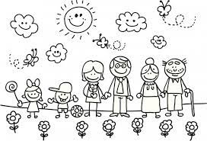
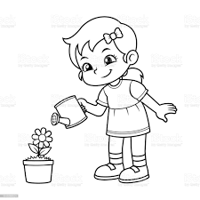
TOPICS ENGLISH
Everyday Activities |  | Our belongings
Vocabulary | Grammar | Vocabulary | Grammar
The time  Actions | Simple Present (Affirmative form)  Identifying sentences | Clothes and accessories  Family members | Demonstrative adjectives  Whose and possessive´s  Types of sentences

