TOPICS FOR THE FINAL EXAM AND TEST PREPARATION
- School supplies – Unit 1
- https://wordwall.net/es/resource/12243014/school-supplies

- Prepositions (on, in, under) – Unit 3
- https://www.liveworksheets.com/es/worksheet/en/english-second-language-esl/180790#google_vignette

- Aquatic animals – unit 5
- https://www.liveworksheets.com/worksheet/en/english-second-language-esl/385491

- Like and don`t like – Unit 8
- https://wordwall.net/es/resource/3575703/i-like-i-dont-like

- Clothes : Unit 6
- https://www.liveworksheets.com/worksheet/en/english-second-language-esl/44881

- Body parts Unit 9
- https://wordwall.net/es/resource/19997504/english/prek-parts-of-the-body

- Adjectives – Unit 9 :
https://www.liveworksheets.com/worksheet/en/english-second-language-esl/380544#google_vignette

- Grammar (I `m - I`m not , he is / he isn`t, She is / She isn`t , They are, they aren`t )
https://wordwall.net/resource/62561780/verb-to-be-negative

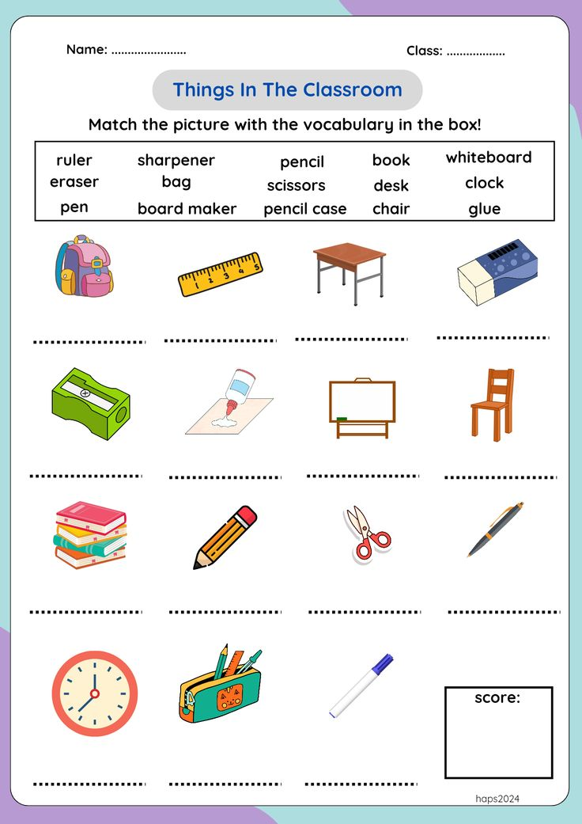

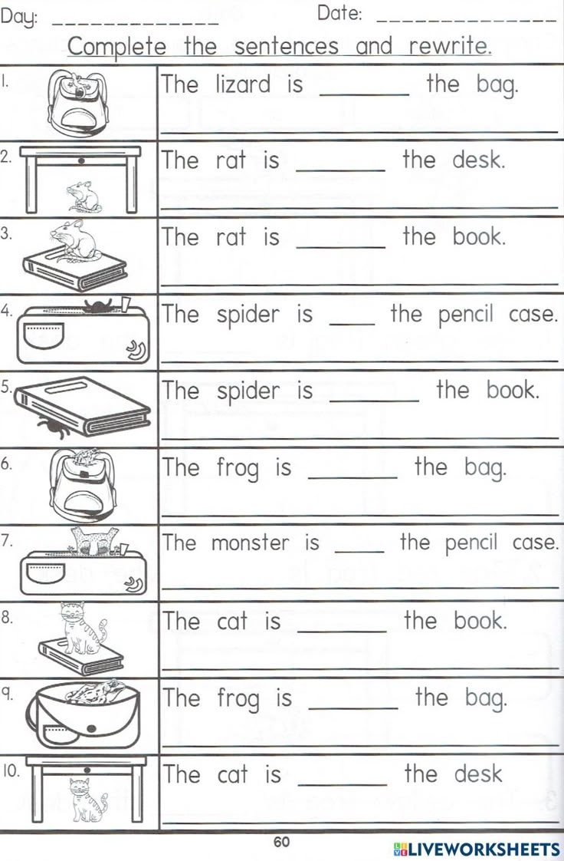

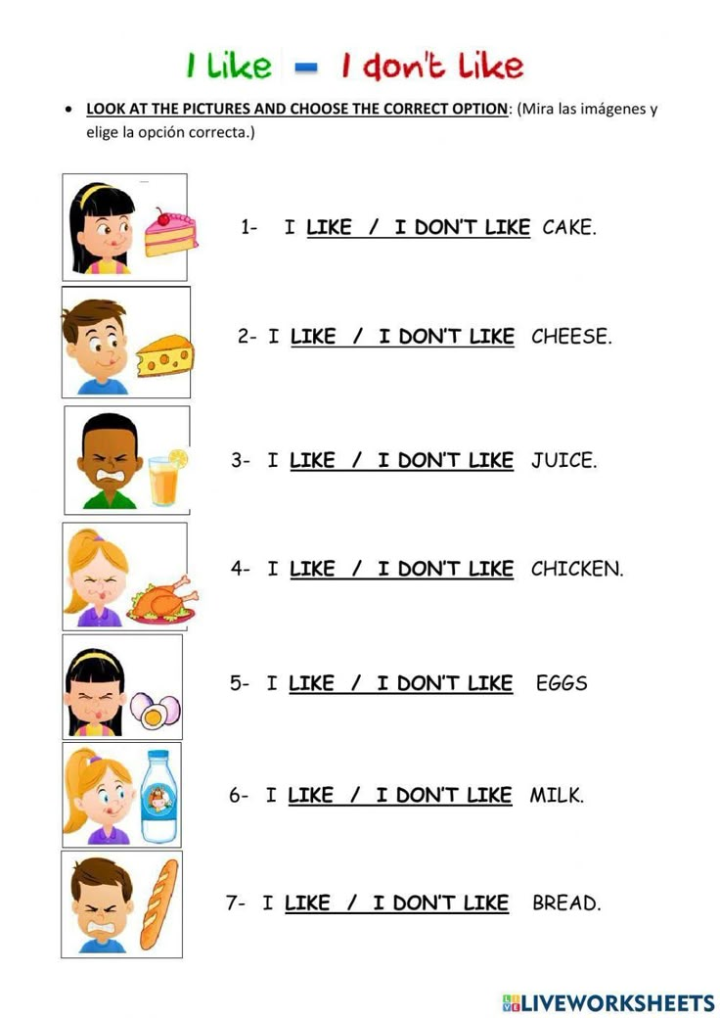V

