My circulatory system
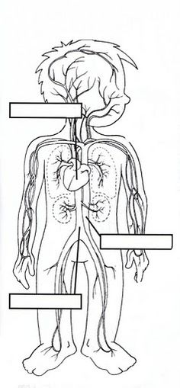

My heart is the motor of our ________________________ system and is the
most special _____________________ that we have.
It is located on the ___________________ side of the center of our chest.
The heart sends ___________________ all over our body.
Blood circulates our bodies through the blood vessels: ____________________,
_______________________ and ___________________________________.

