February 22th, 2021
Lesson
WILD ANIMALS
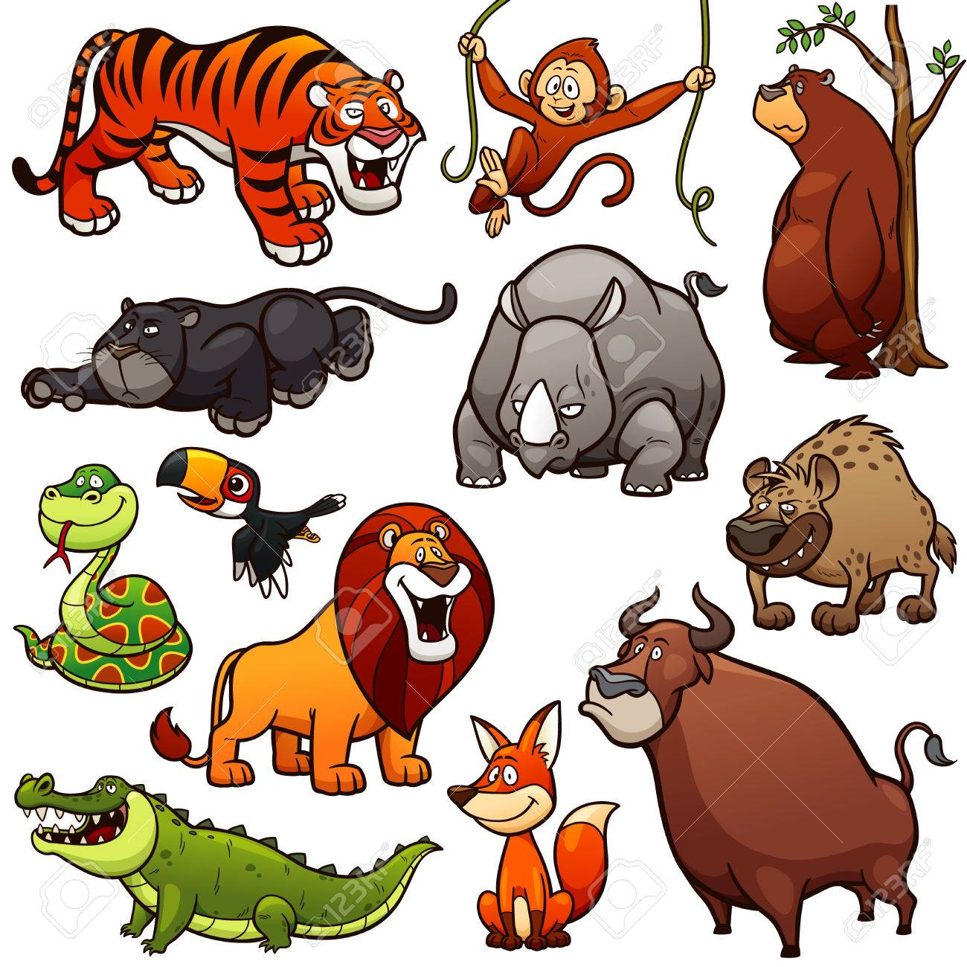

Wild animals are the animal species that grow or live wild in the nature. They can find their own food, shelter, water and all its other needs in a specific natural habitat.

