August 3rd, 2020
Lesson
The Muscles
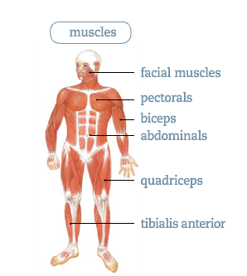
A muscle is an elastic tissue that can contract and expand or shorten and lengthen. Muscles allow us to move in different ways.
Some muscles are voluntary, which means we can move them when we want to.
For example: Our arms and hands allow us to write.
Other muscles are involuntary, which means they move on their own without our control.
For example: The esophagus muscles push food to our stomach and the heart beats by itself.
The human body has about 600 muscles, each with a different function.

