Lesson 17 may 10th
The germination

When a seed is sown into moist soil, it begins to grow. This process is called Germination.
It occurs in the following steps:
1° The seed coat splits
2° A tiny root grows downwards and shoot grows upwards.
3° This produces a seedling of a plant, which ultimately grows into a new
plant.
4° After some time, the plant bears flowers. The flowers produce fruits and
the fruits have seeds in them.
All seeds can germinate when sown in moist soil under suitable conditions to produce new plants.
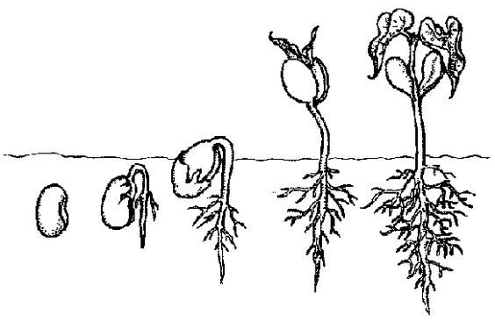
These seeds are sown into the ground again and that is how new plants are born.

1
2
3
4

