Lesson
Habitats: Light or Dark

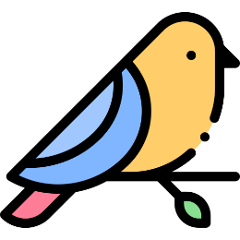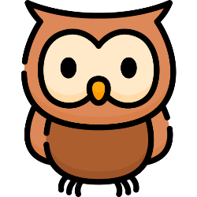

Light is a characteristic of habitats that influences animals. Almost all animals have habitats related to light or darkness.

For example: most birds are awake during the day and live in trees, but bats are awake at night and live in caves.

Most animals use the ground of their habitats to move and find food and some even use it for shelter.

