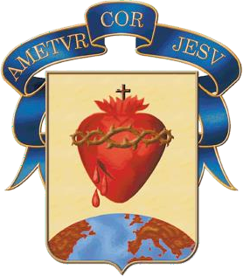
COLEGIO DEL SAGRADO CORAZÓN VÍA PUERTO COLOMBIA
Activity July 29th 2020

The four season animals

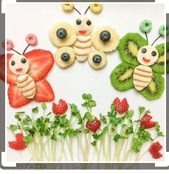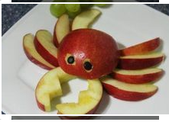

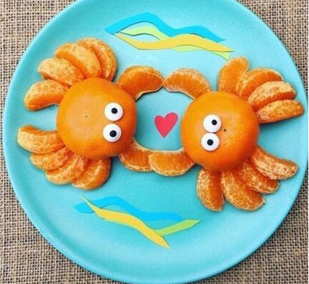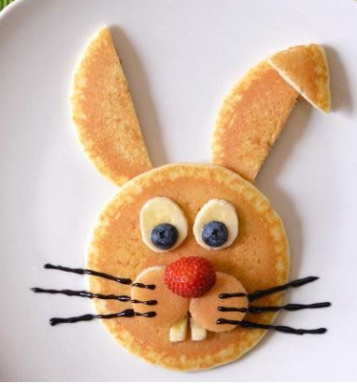

Materials

Strawberries

Tangerines

Kiwi

Banana

Apple

Pancakes or bread.

